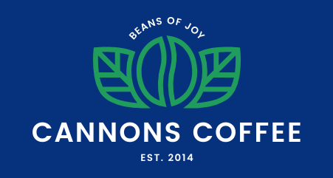

Cannons Coffee Brand Guide
Check the Cannons Coffee folder or see below
for screenshots for how the site should look.

Colors

Color name | Hex value
Black | #000000
Catalina | #06327d
Bluetiful | #2b70e4
Vegan | #209d5c
Sunglow | #ffd034
White | #ffffff
Light Blue | #cadbf8

Font
Font family: Poppins

Element | Font size (rem) | Line height (no units) | Other
h1 | 3rem | 1.1667 | No margin  300 font weight  Uppercase
h2 | 2.5rem | 1.1667 | 300 font weight  Uppercase
h3 | 1.75rem | 1.1667 | 300 font weight
body | 1.125rem | 1.5

Text and Images for Website

Navigation items:
- Home (link to index.html)
  - Hint: the value of your href will be the file path of index.html
- Coffee (link to latte.html)
  - Hint: the value of your href will be the file path of latte.html
- About (link to your favorite coffee house’s website, open in new tab)
- Contact (when clicked, opens an email to your professional email address. You may need to look this up!)

Use logo-nav.png as the logo for the website. Don’t forget the alt attribute!
On CodePen: https://assets.codepen.io/296057/logo-nav.png
Alt text: Cannons Coffee Logo, Beans of Joy

Home page opening text

Coffee and Code
Join us at Cannons Coffee for a pick-me-up and plenty of code assistance and support at our coding cafe
Reserve a table (have the link go to any website of your choice)
Image: coffee-computer.jpg
On CodePen: https://assets.codepen.io/296057/coffee-computer.jpg
Alt text: Laptop with a cup of coffee and a glass of water

Our Coffee
Latte
Hot or cold, with dairy or oat milk, your favorite is available anytime!
Order Latte (have the link go to any website of your choice)
Image: latte.jpg
On CodePen: https://assets.codepen.io/296057/latte.jpg
Alt text: Latte in a cup

Coffee
Simple, elegant, and always in style, our black coffee comes from Colombia in small, hand-roasted batches.
Order Coffee (have the link go to any website of your choice)
Image: coffee.jpg
On CodePen: https://assets.codepen.io/296057/coffee.jpg
Alt text: Coffee in a cup

Hot Chocolate
Not a coffee person? We have you covered. Hot, sweet, ready anytime.
Order Hot (have the link go to any website of your choice)
Image: hotchoc.jpg
On CodePen: https://assets.codepen.io/296057/hotchoc.jpg
Alt text: Hot Chocolate in a cup with whipped cream

Iced Coffee
Perfect for hot summer days, our iced coffee is made with just enough sweetness to cool down your day.
Order Iced (have the link go to any website of your choice)
Image: iced.jpg
On CodePen: https://assets.codepen.io/296057/iced.jpg
Alt text: Iced coffee in a mug with a straw

Footer
[copyright symbol] 2026 Cannons Coffee. All Rights Reserved.

Image: logo-footer.png
On CodePen: https://assets.codepen.io/296057/logo-footer.png
Alt text: Cannons Coffee, Beans of Joy! Est. 2014

Cafe Latte page
Cafe Latte
One shot of espresso coffee plus plenty of steamed milk. Choose skim milk, regular milk, or oat milk.
Order Now (have the link go to any website of your choice)
Image: latte.jpg
On CodePen: https://assets.codepen.io/296057/latte.jpg
Alt text: Coffee in a cup

Recommended approach:
- Cannons Coffee: Annotating Designs Assignment
  - Review the designs provided in the Google Drive folder. What changes at different dimensions? Annotate your images and turn this into the first assignment.
    - Have an instructor check your annotations before you start coding
- Cannons Coffee: Task List Assignment
  - Make a list of all of the tasks you'll need to complete to work on this assignment. Try to put these in order. This will be your second assignment.
Examples:
    - Code a navbar (with what layout?)
    - Code the cards (with what layout?)
    - Setup my variables
    - Link to Google Fonts
- Cannons Coffee: GitHub and GitHub Pages Assignment
  - Note: You may start coding in CodePen first and then transfer to VSCode or directly start in VSCode.
    - If you are starting in CodePen, fork the starting CodePen from Monday and add your code there.
    - If you are directly starting in VSCode, you already have the files and folders created in VSCode from Monday. You can open that project folder and add your code there.
  - Start with the MOBILE homepage design FIRST.
    - Get the content into the HTML by copying and pasting from this document.
    - Mark it up with good HTML.
    - Wrap a container around everything except <body></body> and set a max width of 1200px, and center on the page using margin. This keeps the content from getting too wide and from bumping into the side of the page.
    - Create your CSS file and link it to your HTML page.
    - Set up your CSS variables for fonts and colors (mentioned above in this Brand Guide).
    - Set up your basic page styling. What elements will get reused? (Headings, body text, button styling, etc)
    - Code from top to bottom, addressing each section of the page with layout and colors.
    - Get this as close to the design screenshots as possible!
  - NOW compare your mobile design with the tablet design. What changes must be made for the screen size? Write styles for the tablet design that will override the default mobile styles.
  - Compare the tablet design with the desktop design and do the same thing.
  - When your home page is complete, create a new file for your latte.html page.
  - Copy over any HTML code that is the same in homepage and latte.
  - Then add the content and changes for the latte.html page.
  - Now, you may create a new CSS file specifically for latte.html OR you may link your existing CSS file to your latte.html file and add any new styles there
  - Add your styles for the latte page, starting from mobile, then for tablet and then for desktop. Double-check how it looks at each breakpoint.
  - Link the navbar as described. Link the latte ordering button to the latte.html page.
  - Test everything carefully! Make sure links work, images are displayed correctly and your layouts are responsive for each screen size..
  - Post to Github and Github Pages. Your repo should be called cannons-coffee.
  - Turn in links to your repo and to your Github Pages URL.

Pro Tips
Working in VS Code?
If you are working in VS Code and want to check your code for errors, look out for yellow squiggly underlines which will be pointing you to error messages. When you hover on the part of code that has an error, it will give you a hint or point you to what the error is.

Home page - mobile (goes 0 to 649px)
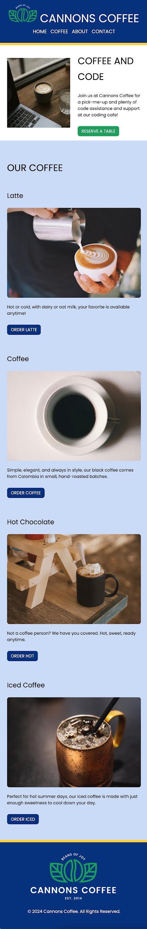

Home page - tablet (starts at 650px)
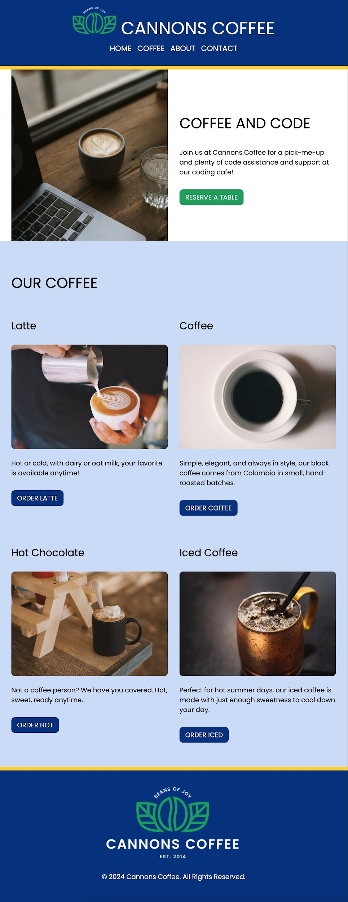

Home page - desktop (starts at 1000px)
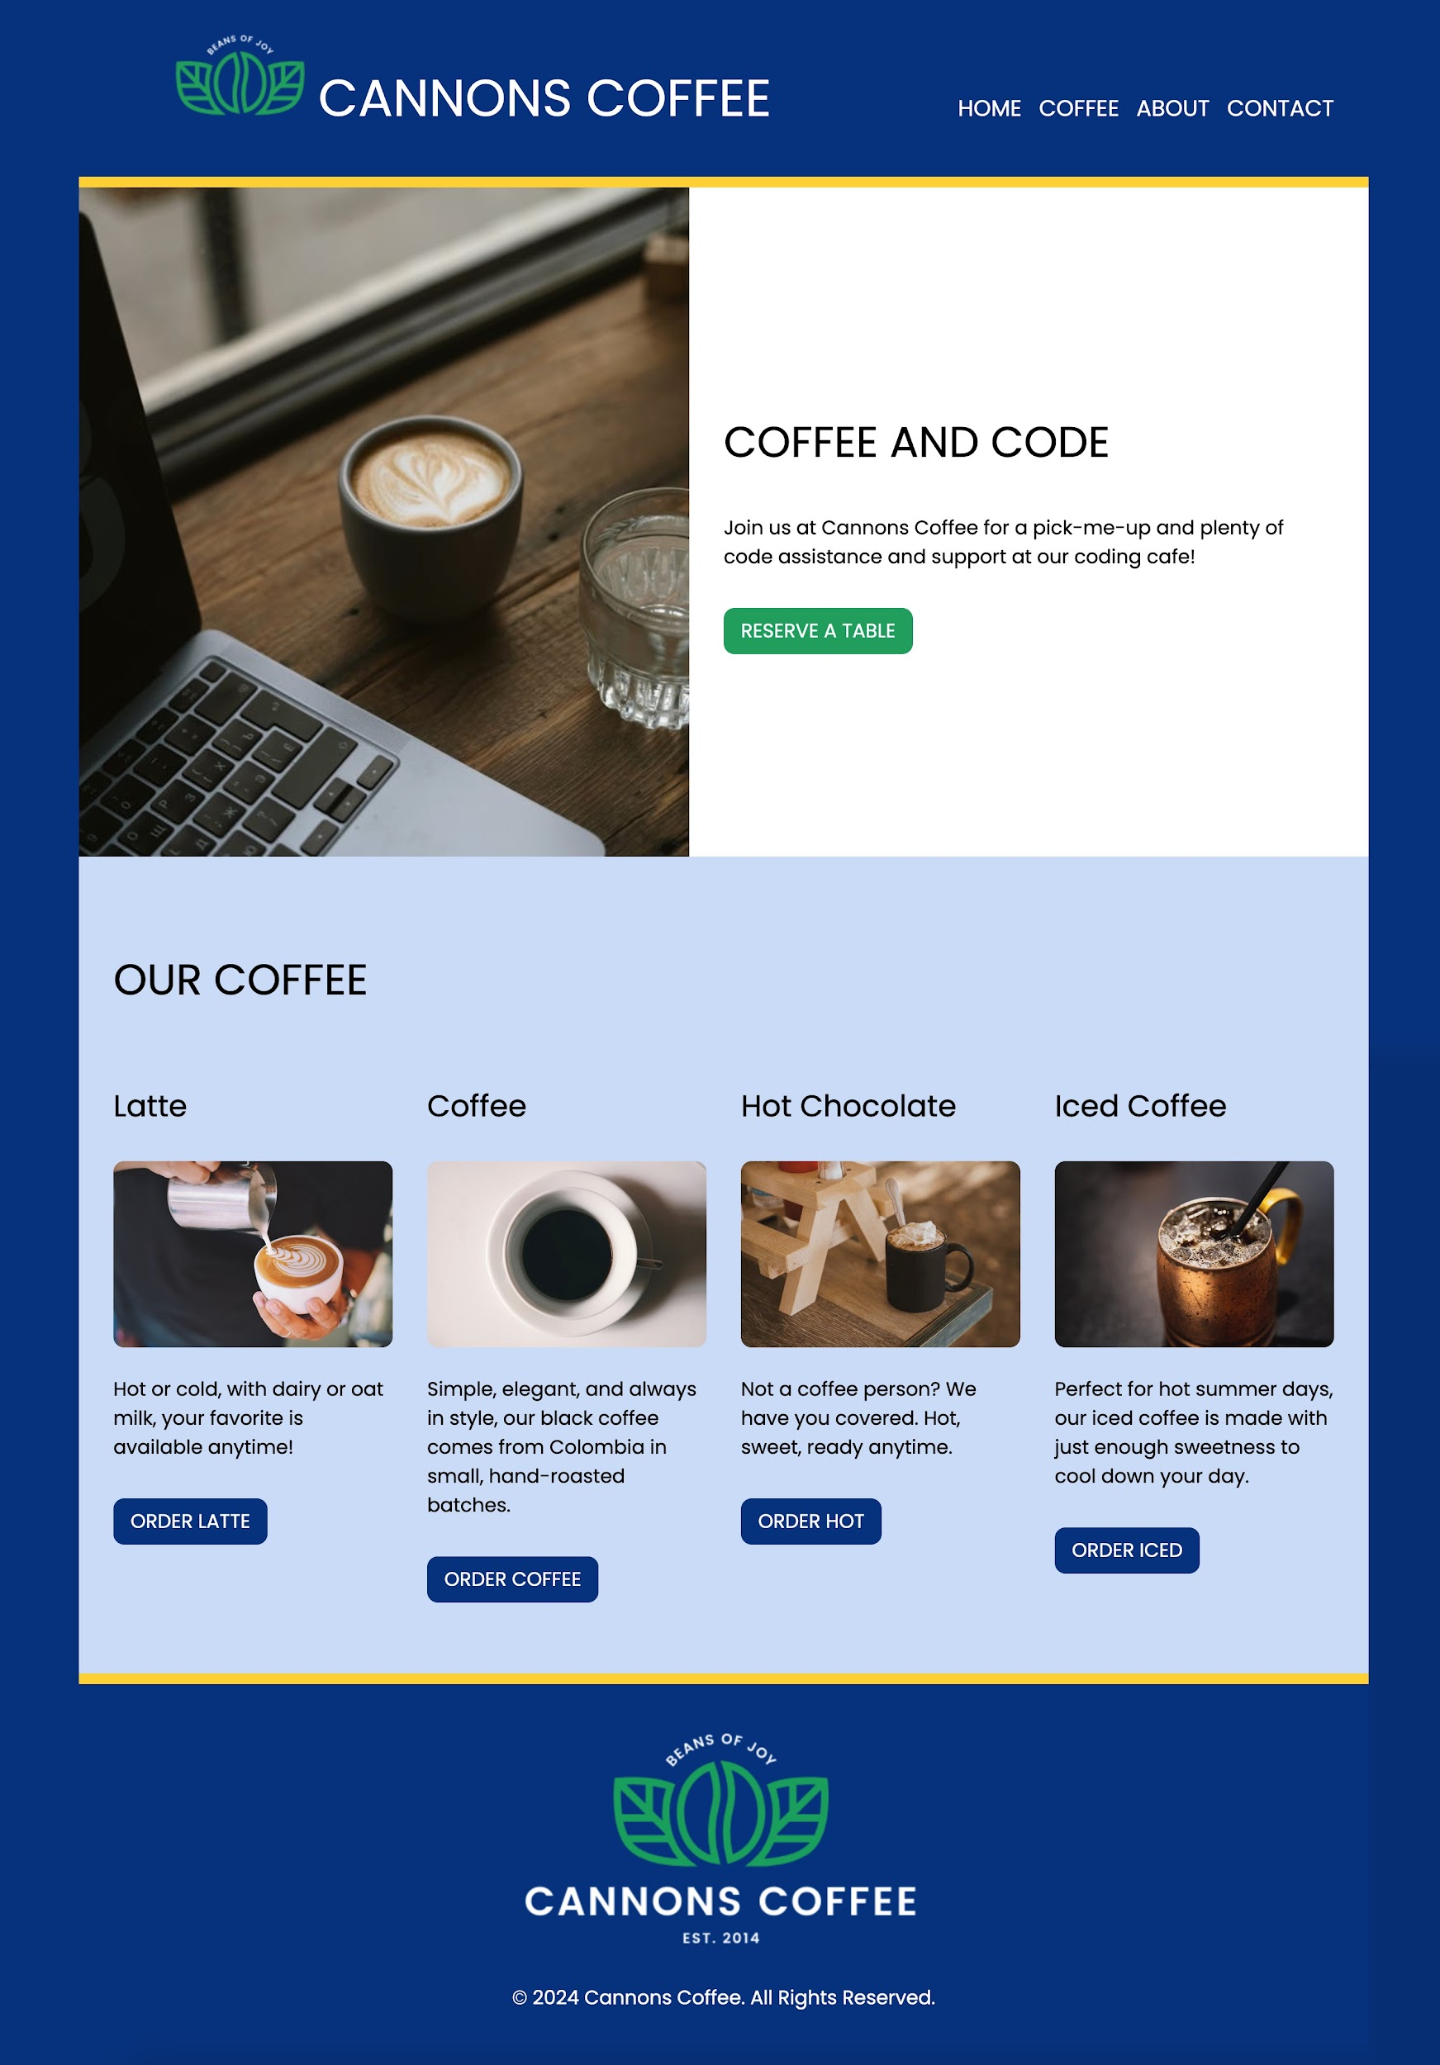

Latte page - mobile/tablet (these are the same design!)
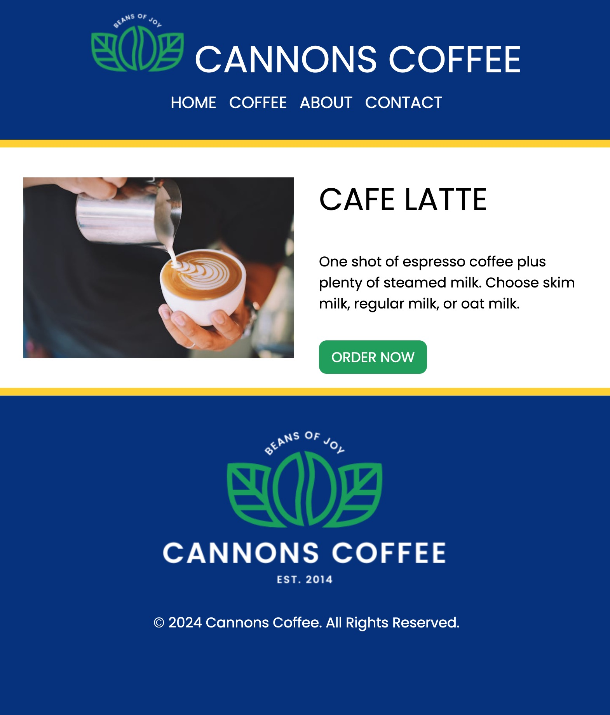

Latte page - desktop
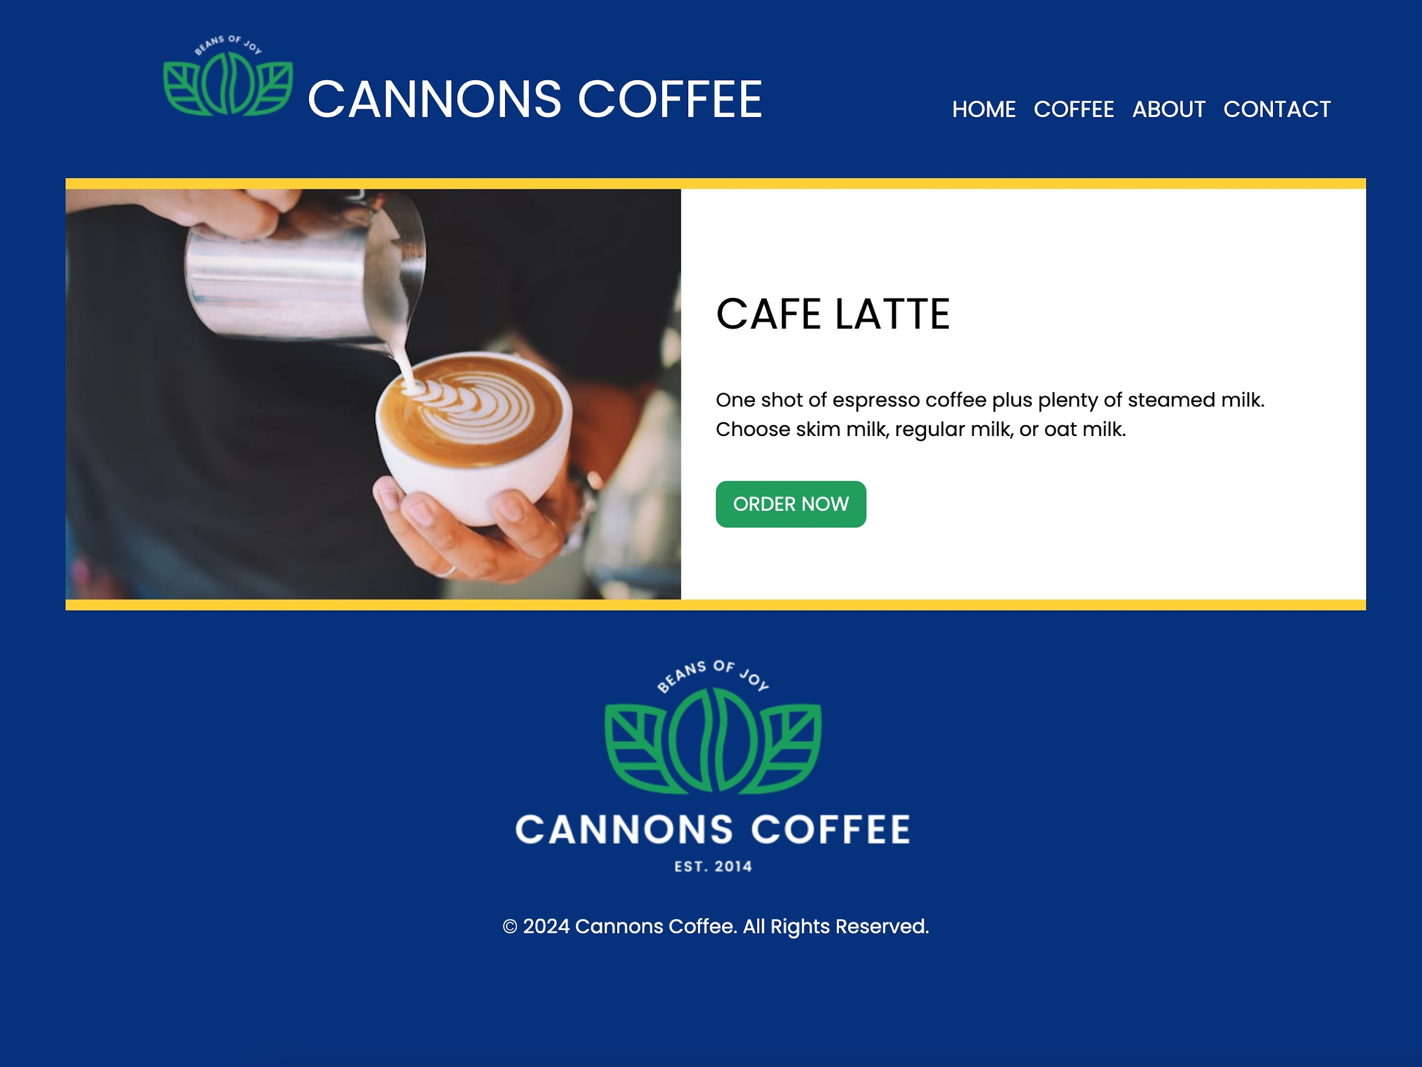

Photo credits
Photo by Olena Bohovyk: Free Modern Laptop and Coffee on Cafe Table Stock Photo

Photo by Chevanon Photography: Free Person Holding White Cup Stock Photo

Photo by Brigitte Tohm: Free Black Liquid in White Ceramic Mug Stock Photo

Photo by Marta Wave: Free Cup of cocoa with whipped cream Stock Photo

Photo by Ryutaro Tsukata: Coffee with crystal ice in shiny cup · Free Stock Photo

Logo: Dark Green and Gold Coffee Bean Modern Logo by Soni Sokell, Canva

